nome:talita oliveira silva de Albuquerque

matrícula:01811203

curso:ADS

<!DOCTYPE html>

<html lang="pt-BR">

<head>

<meta charset="UTF-8" />

<meta name="viewport" content="width=device-width, initial-scale=1.0" />

<title>React - Jogo da Velha</title>

<script src="https://unpkg.com/react@17/umd/react.development.js"></script>

<script src="https://unpkg.com/react-dom@17/umd/react-dom.development.js"></script>

<script src="https://unpkg.com/@babel/standalone/babel.min.js"></script>

<style>

.board-row {

display: flex;

}

.square {

width: 60px;

height: 60px;

background: #fff;

border: 1px solid #999;

font-size: 24px;

font-weight: bold;

text-align: center;

line-height: 60px;

cursor: pointer;

}

.status {

margin-bottom: 10px;

font-weight: bold;

}

</style>

</head>

<body>

<div id="root"></div>

<script type="text/babel">

function Square({ value, onSquareClick }) {

return (

<button className="square" onClick={onSquareClick}>

{value}

</button>

);

}

function Board({ xIsNext, squares, onPlay }) {

function handleClick(i) {

if (squares[i] || calculateWinner(squares)) return;

const nextSquares = squares.slice();

nextSquares[i] = xIsNext ? "X" : "O";

onPlay(nextSquares);

}

const winner = calculateWinner(squares);

let status;

if (winner) {

status = "Vencedor: " + winner;

} else {

status = "Próximo jogador: " + (xIsNext ? "X" : "O");

}

return (

<>

<div className="status">{status}</div>

<div className="board-row">

<Square value={squares[0]} onSquareClick={() => handleClick(0)} />

<Square value={squares[1]} onSquareClick={() => handleClick(1)} />

<Square value={squares[2]} onSquareClick={() => handleClick(2)} />

</div>

<div className="board-row">

<Square value={squares[3]} onSquareClick={() => handleClick(3)} />

<Square value={squares[4]} onSquareClick={() => handleClick(4)} />

<Square value={squares[5]} onSquareClick={() => handleClick(5)} />

</div>

<div className="board-row">

<Square value={squares[6]} onSquareClick={() => handleClick(6)} />

<Square value={squares[7]} onSquareClick={() => handleClick(7)} />

<Square value={squares[8]} onSquareClick={() => handleClick(8)} />

</div>

</>

);

}

function Game() {

const [history, setHistory] = React.useState([Array(9).fill(null)]);

const [currentMove, setCurrentMove] = React.useState(0);

const xIsNext = currentMove % 2 === 0;

const currentSquares = history[currentMove];

function handlePlay(nextSquares) {

const nextHistory = [...history.slice(0, currentMove + 1), nextSquares];

setHistory(nextHistory);

setCurrentMove(nextHistory.length - 1);

}

function jumpTo(move) {

setCurrentMove(move);

}

const moves = history.map((squares, move) => {

let description;

if (move > 0) {

description = "Ir para jogada #" + move;

} else {

description = "Ir para o início do jogo";

}

return (

<li key={move}>

<button onClick={() => jumpTo(move)}>{description}</button>

</li>

);

});

return (

<div className="game">

<div className="game-board">

<Board xIsNext={xIsNext} squares={currentSquares} onPlay={handlePlay} />

</div>

<div className="game-info">

<ol>{moves}</ol>

</div>

</div>

);

}

function calculateWinner(squares) {

const lines = [

[0, 1, 2],

[3, 4, 5],

[6, 7, 8],

[0, 3, 6],

[1, 4, 7],

[2, 5, 8],

[0, 4, 8],

[2, 4, 6],

];

for (let i = 0; i < lines.length; i++) {

const [a, b, c] = lines[i];

if (squares[a] && squares[a] === squares[b] && squares[a] === squares[c]) {

return squares[a];

}

}

return null;

}

ReactDOM.render(<Game />, document.getElementById("root"));

</script>

</body>

</html>

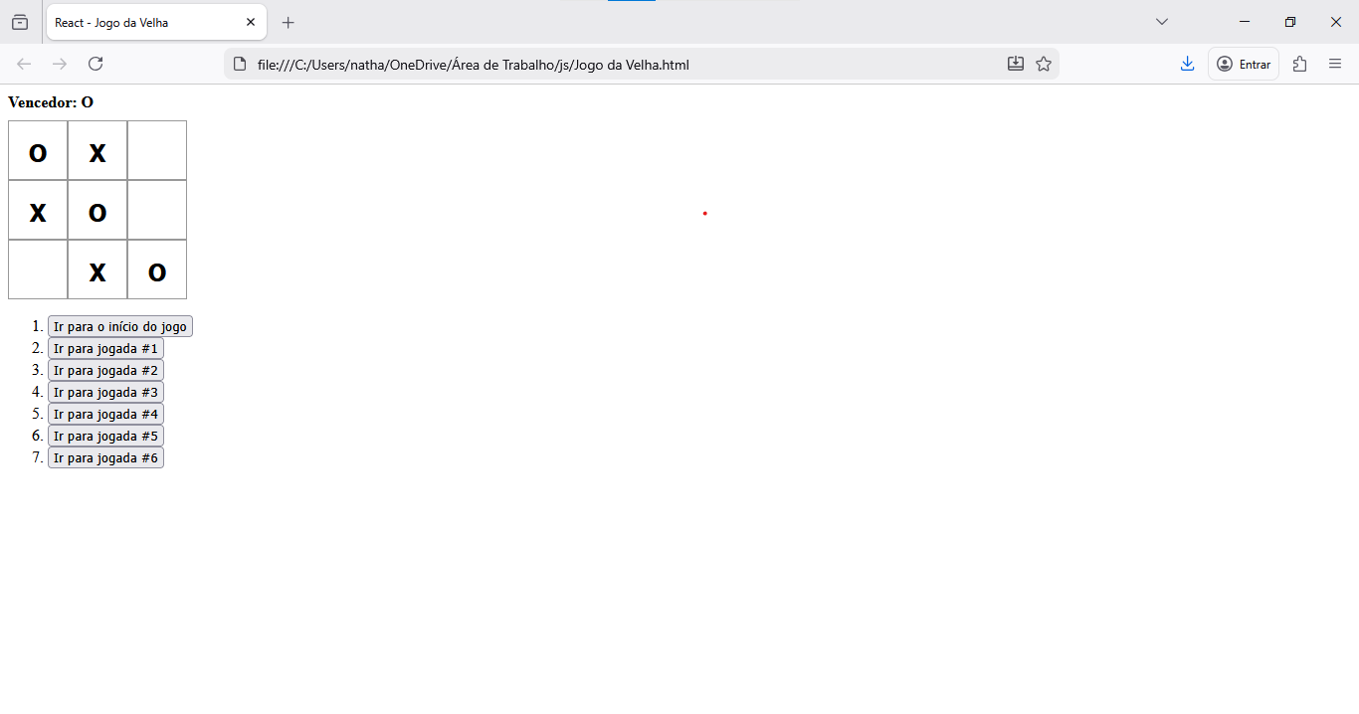

file:///C:/Users/natha/OneDrive/%C3%81rea%20de%20Trabalho/js/Jogo%20da%20Velha.html

file:///C:/Users/natha/Downloads/jovodavelha.html